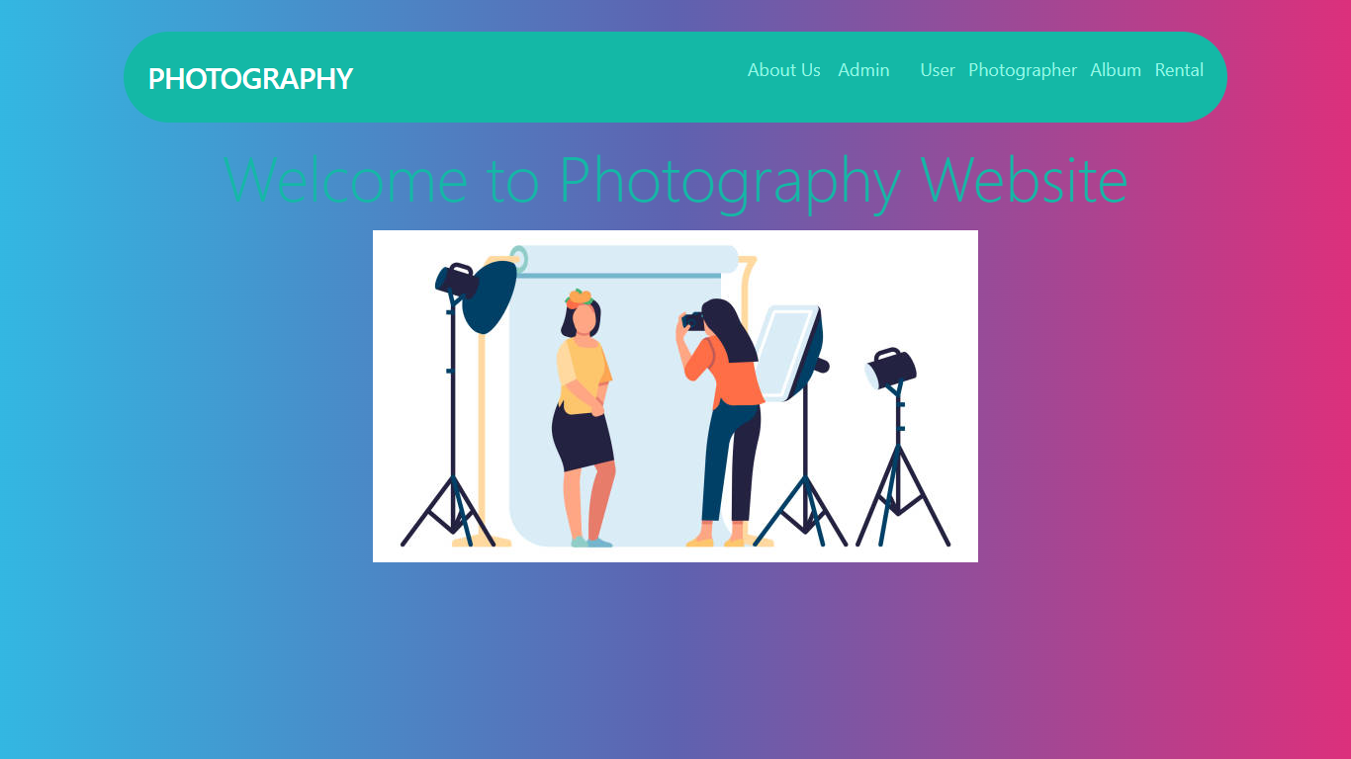

**Home :** This is the home page our project.

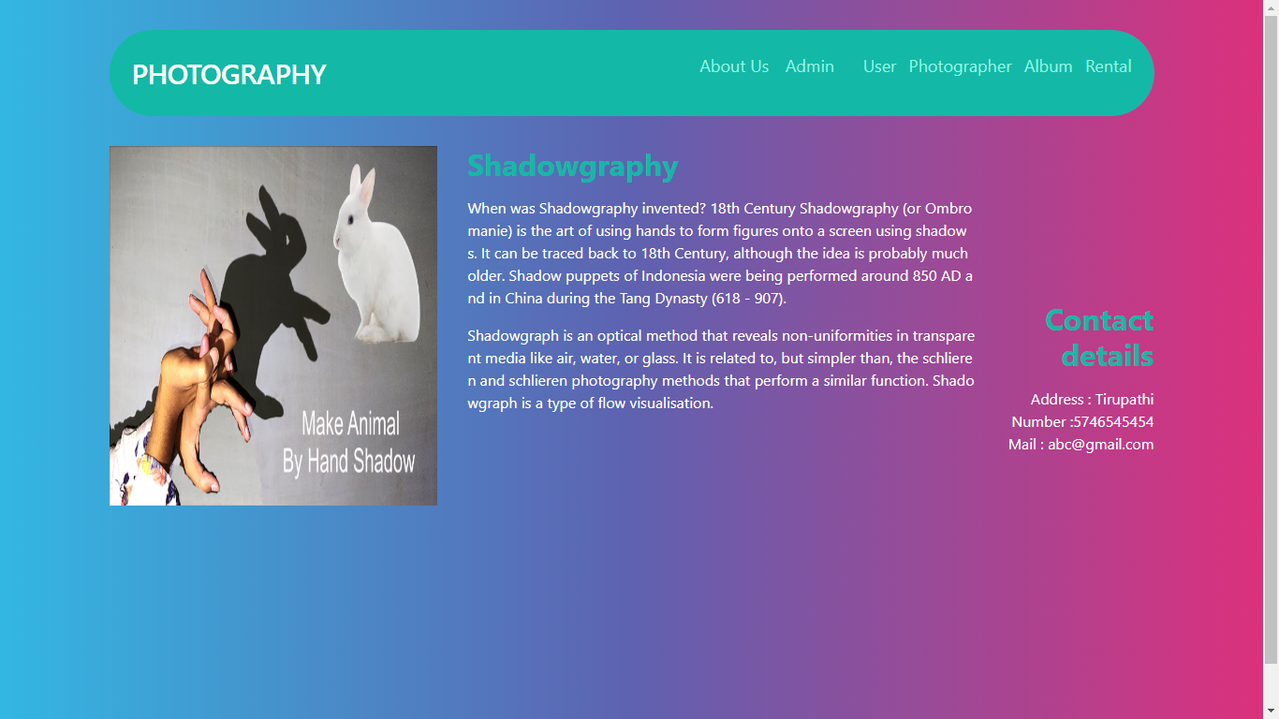

**About Us:** This is the page inside about us about shadowgraphy.

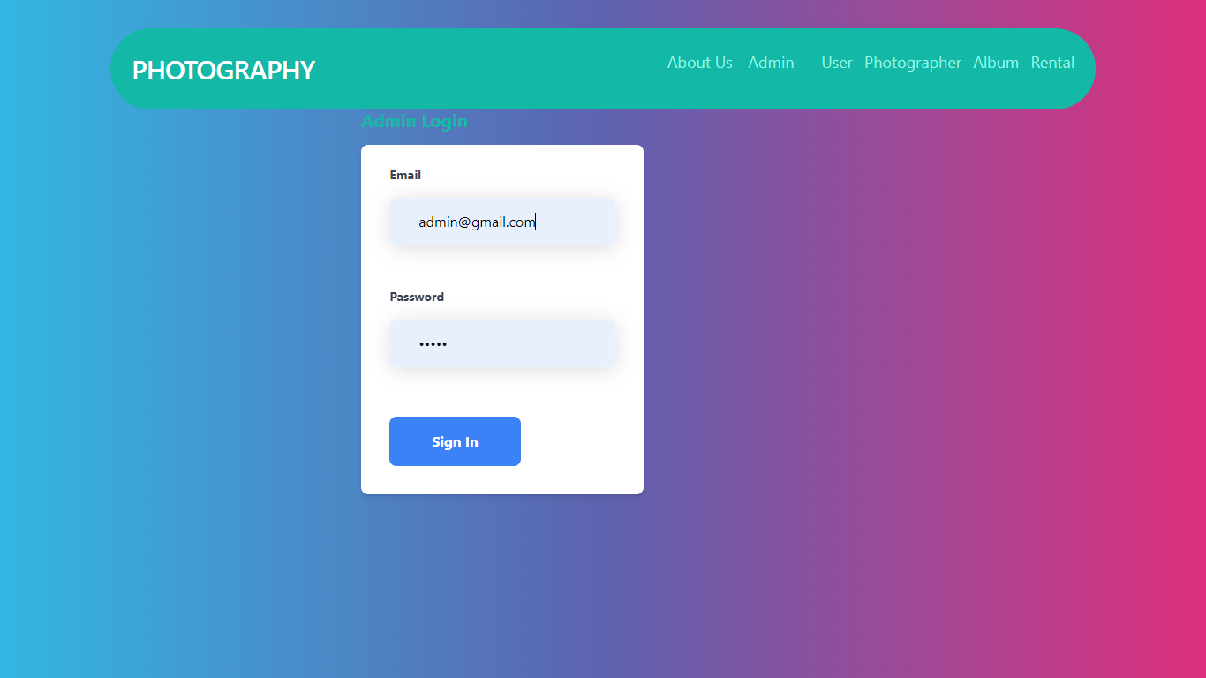

**Admin Login:** This is admin Login page, login with default credentials like [admin@gmail.com](mailto:admin@gmail.com) and admin.

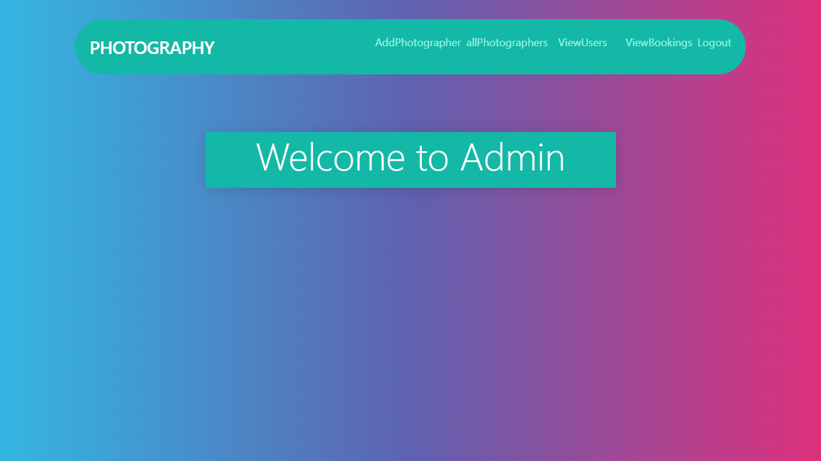

**Admin Home:** This is admin home page.

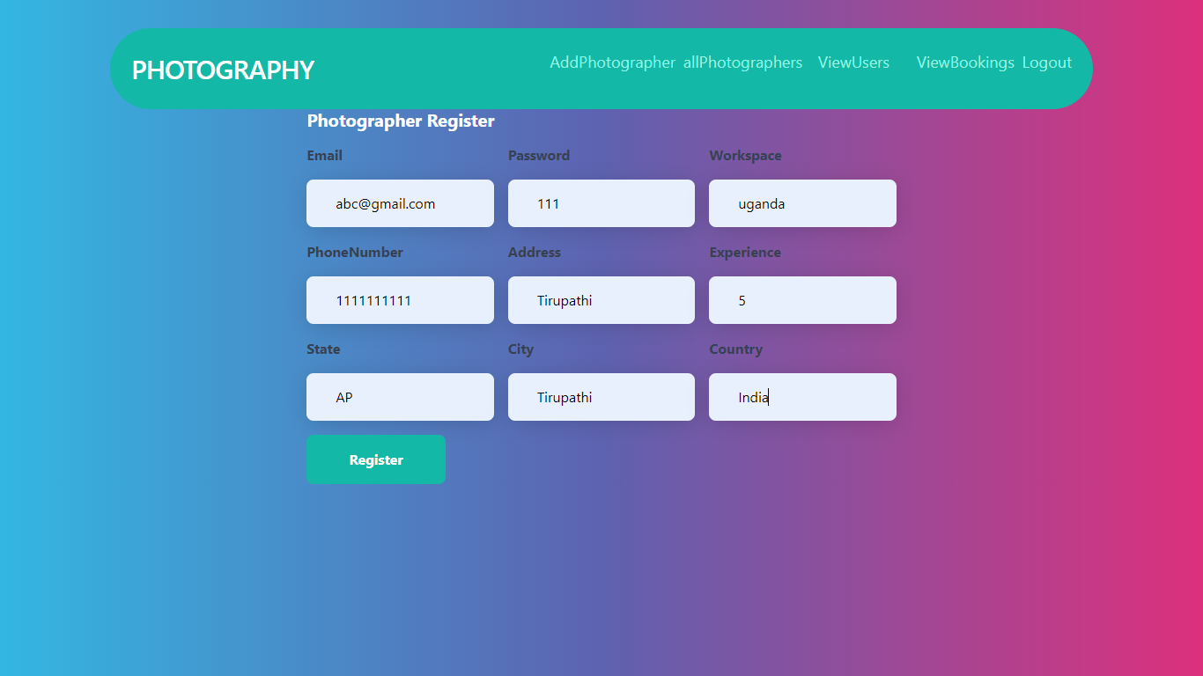

**Add Photographer:** Here admin can add photographers.

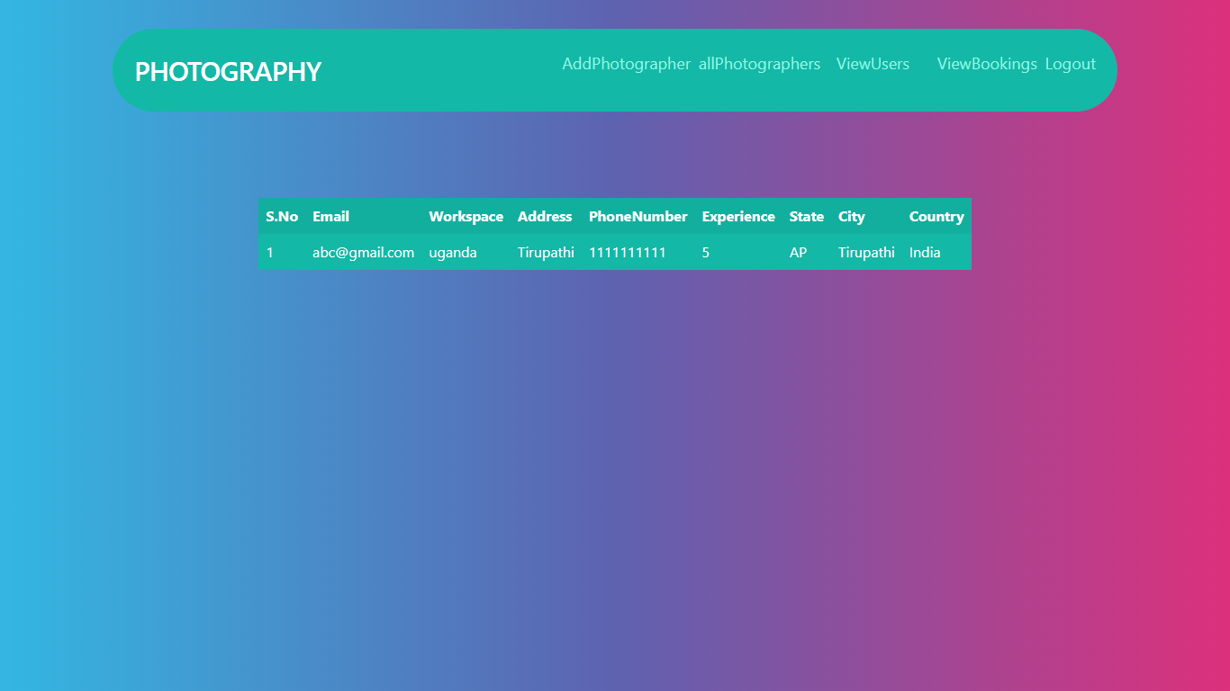

**View Photographers:** Here admin view all Photographers which are already added.

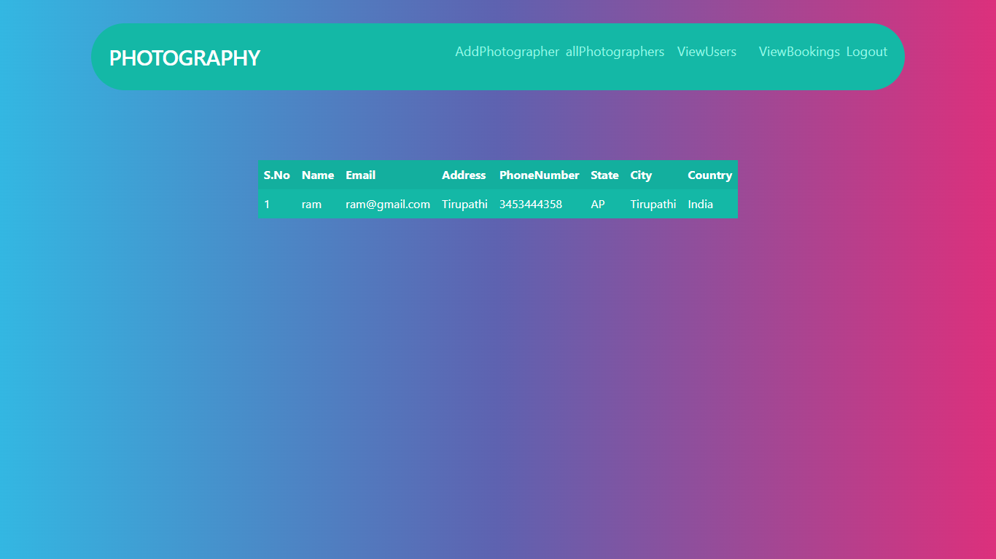

**View Users:** Here admin view all users who are registered.

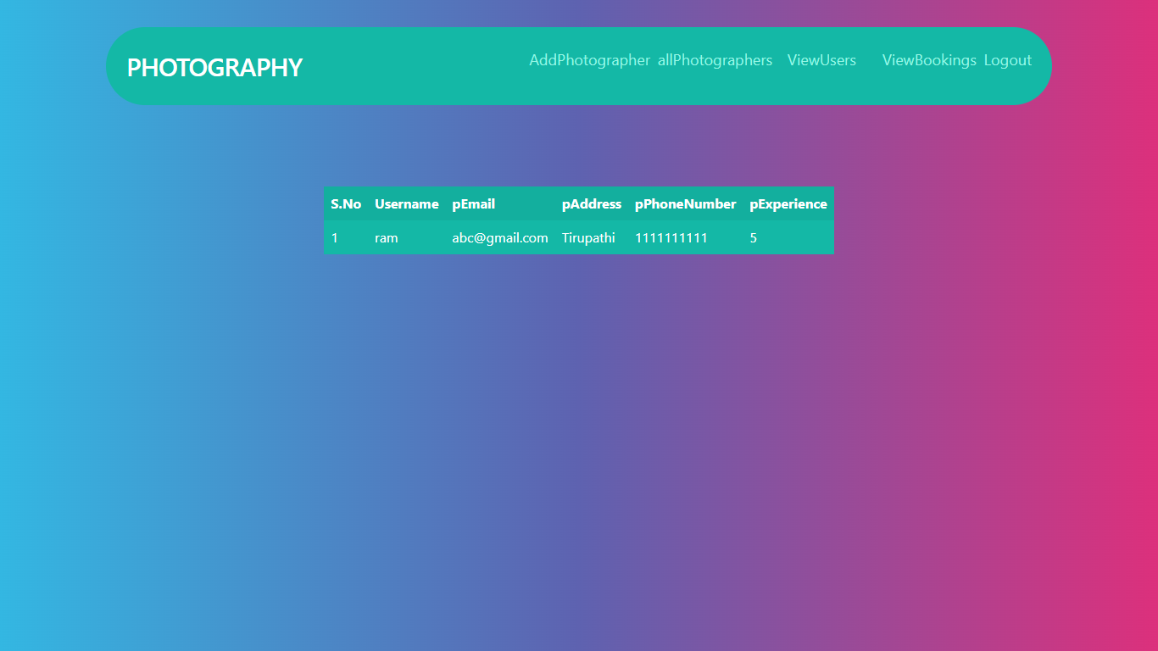

**View Bookings:** Here admin view all bookings by the users.

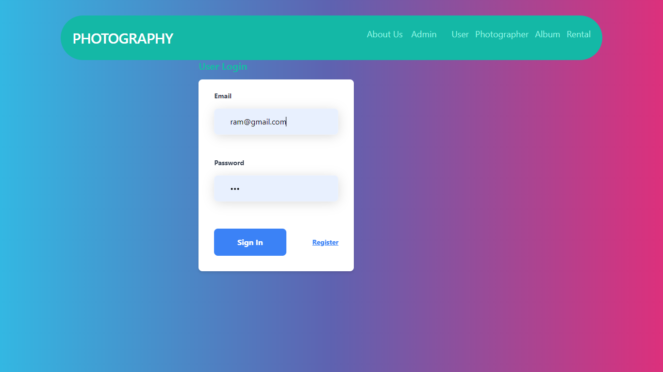

**User Login:** Here user can login with their required details.

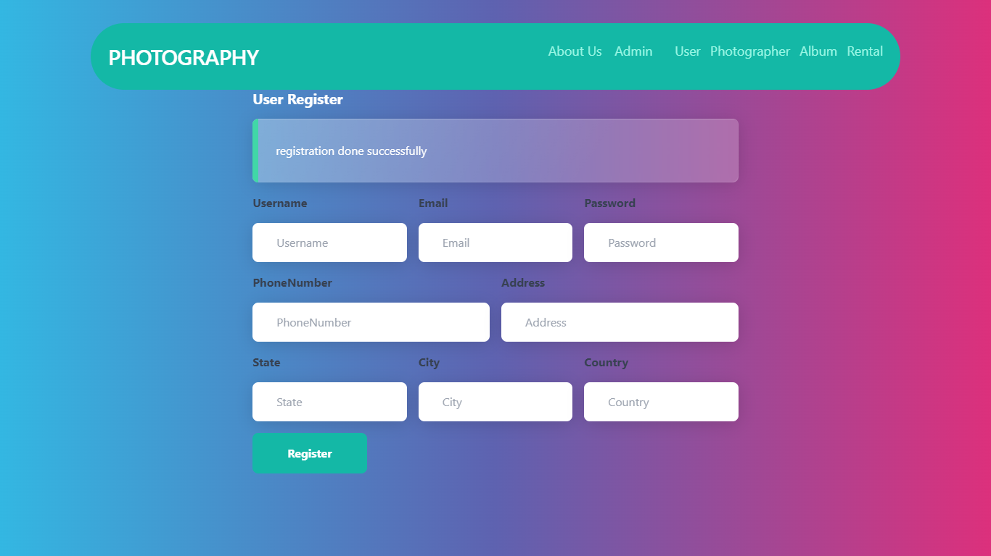

**User Register:** If the user login first time then must be register with these page.

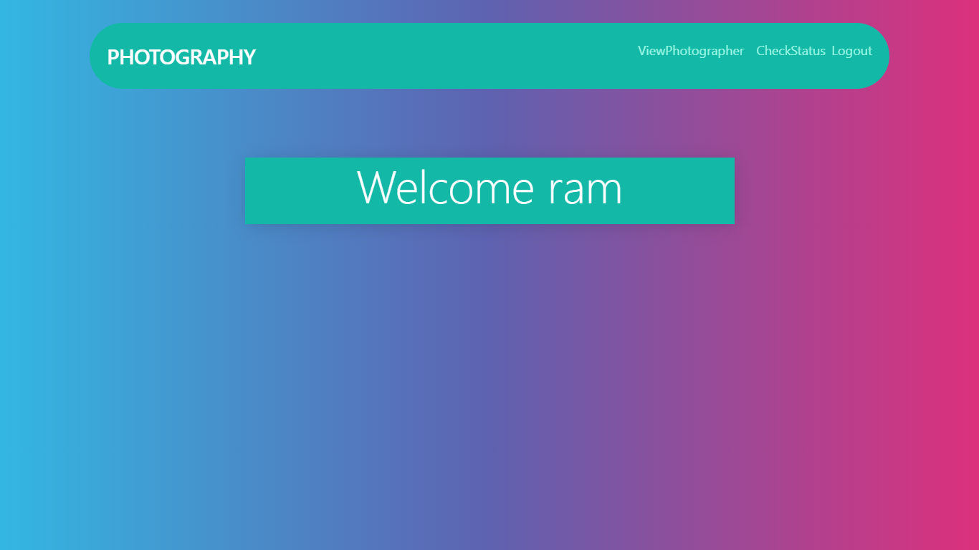

**User Home:** This is the user home page.

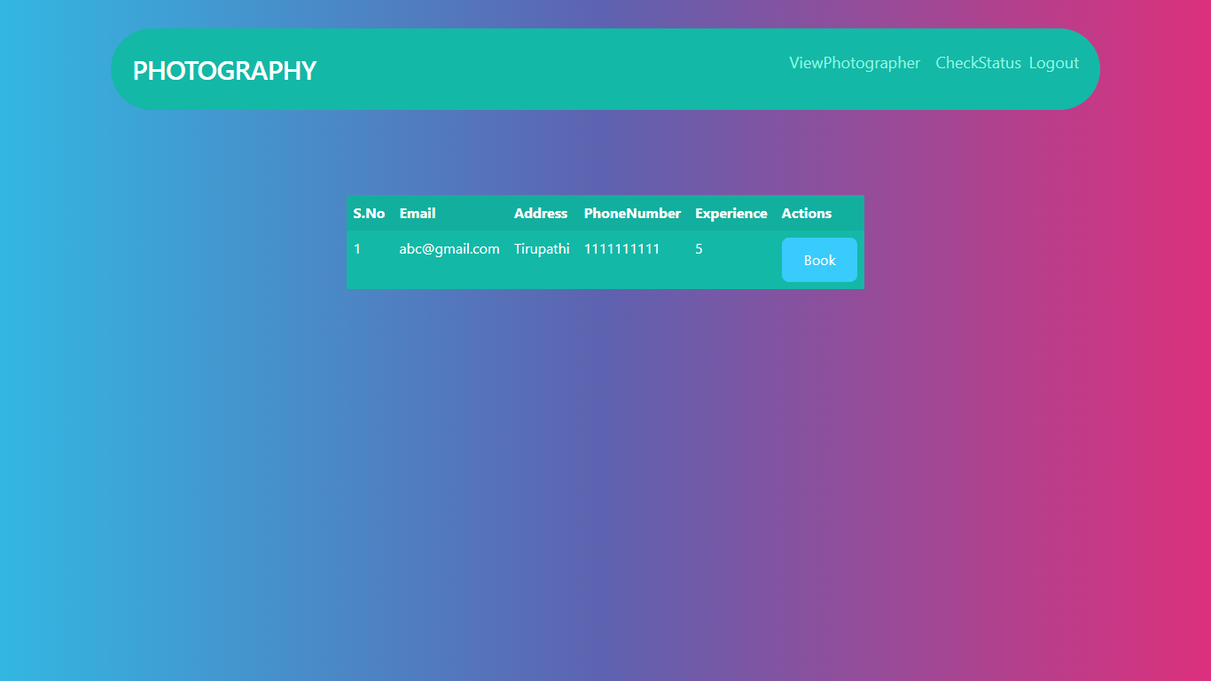

**User booking page:** After login user can view photographers and book particular photographer.

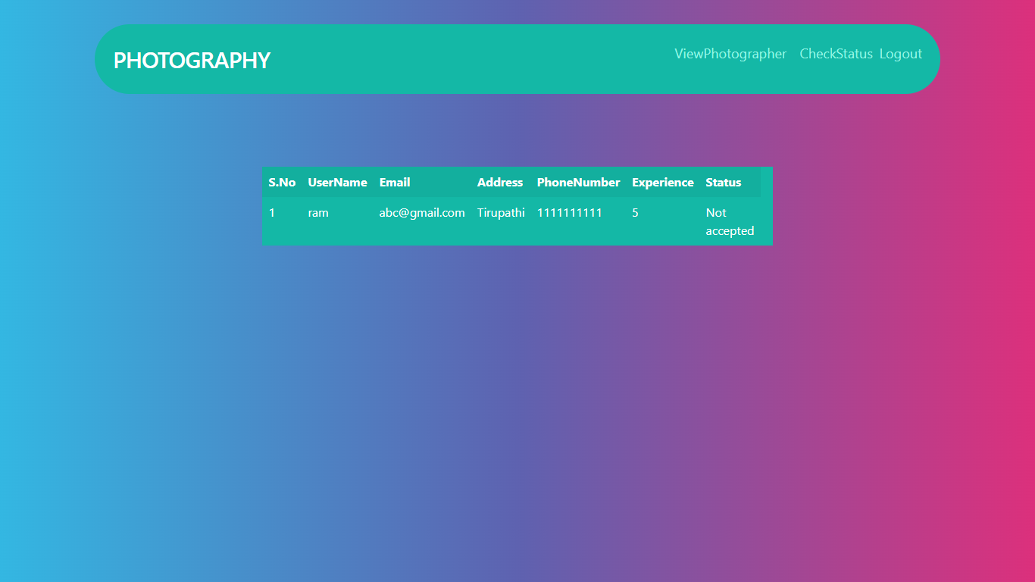

**Check Status:** User can check the status its accepted or not by the photographer.

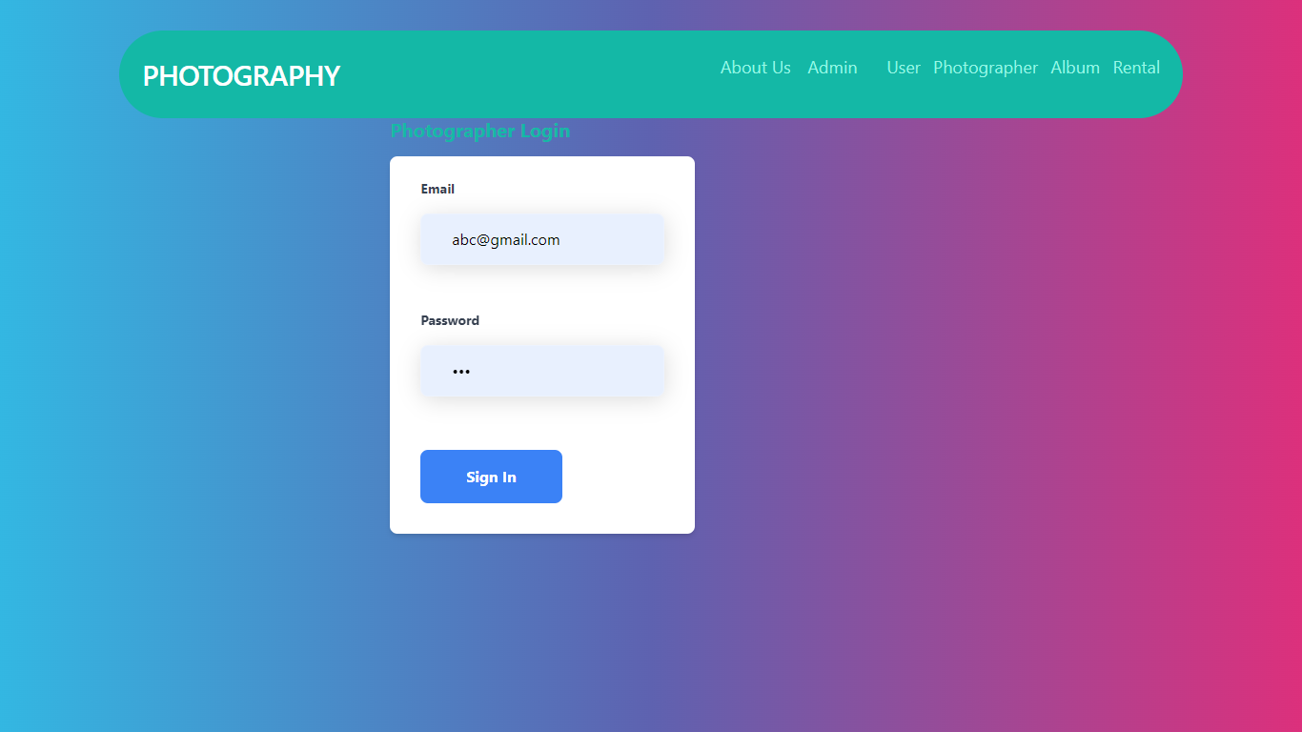

**Photographer login:** Here photographer login with required credentials which are added by the admin.

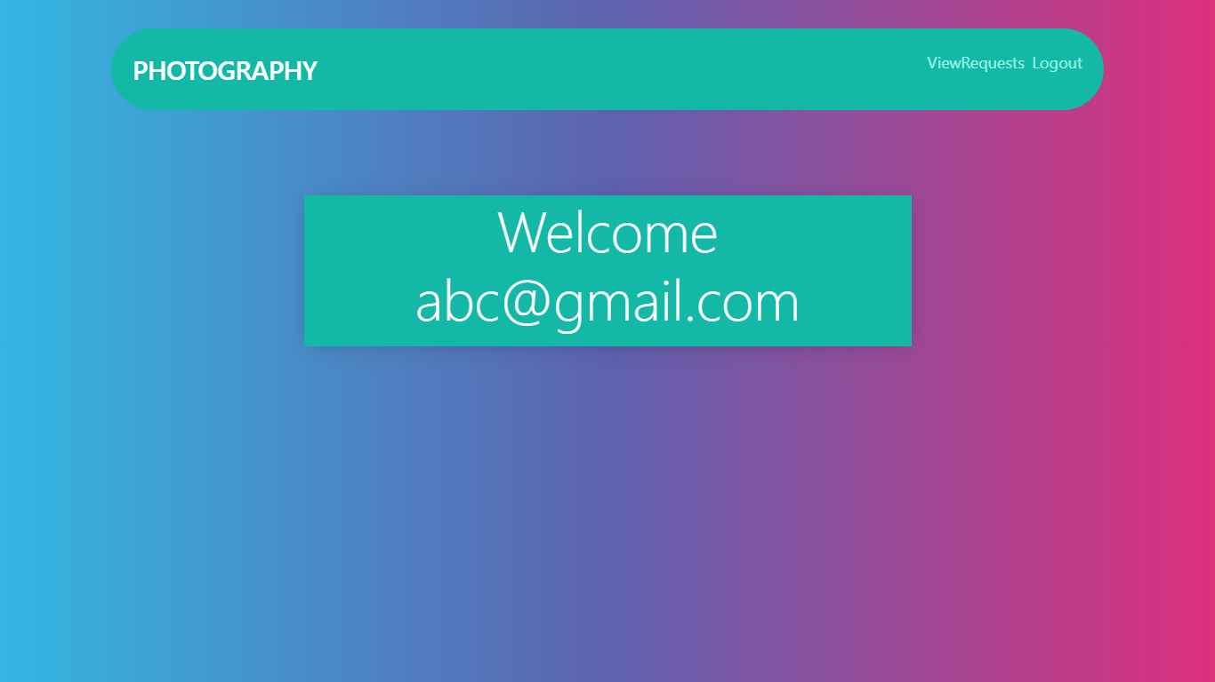

**Photographer Home:** This is the photographer home page.

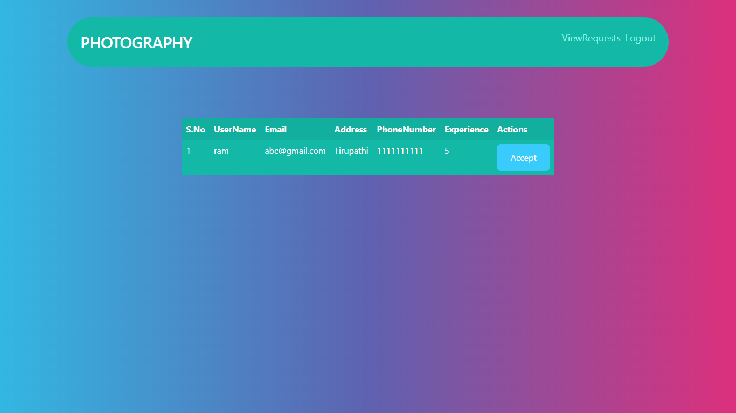

**View Requests:** Here photographer can view all the requests which are booked by the user.

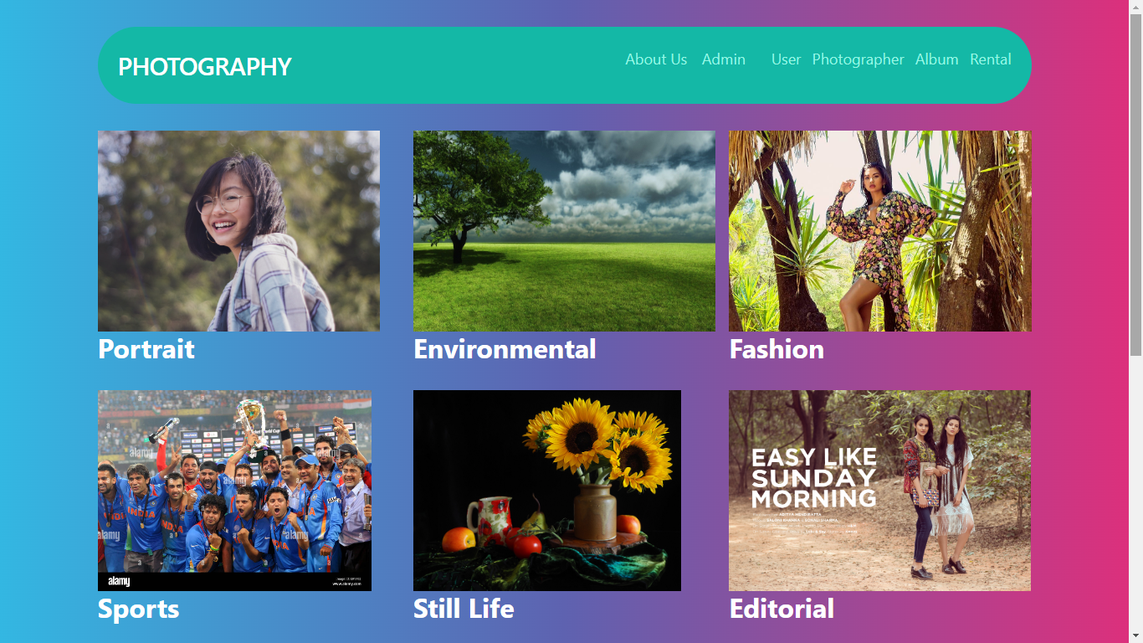

**Album:** This is the album page here we can see different types of photographs.

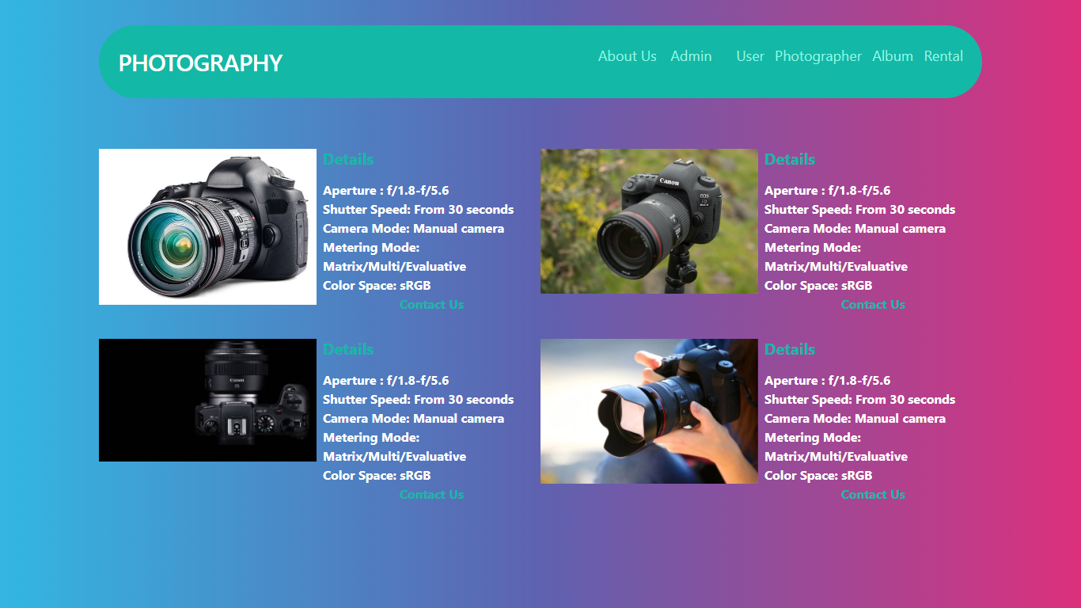

**Rentals:** This is rentals page here we can see some rentals cameras.